Younis Ghirfani

Design Manual
Younis Ghirfani
Table of Contents
Abstract 2
Introduction 2
GUI 6

Abstract
Having a user interface is crucial as it allow the display some design and style to the user. Also, with many GUI packages available there is options to how the back-end developer will approach

Introduction
This document will outline the procedure involved in the design process for this application. This was achieved using pre-existing software technologies to utilise Benford’s Law to verify the legitimacy of an image. The type of images this application is verifying is called Deep Fake images, which are doctored images in a malicious style.

GUI
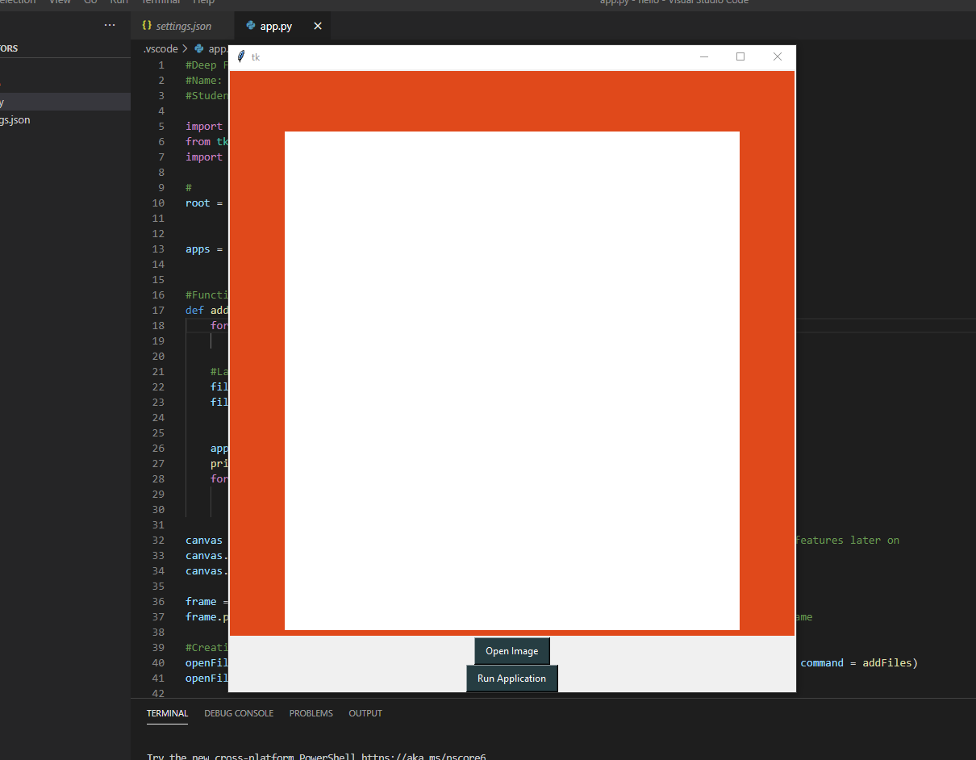
My initial style was orange with a graph in the middle displaying data

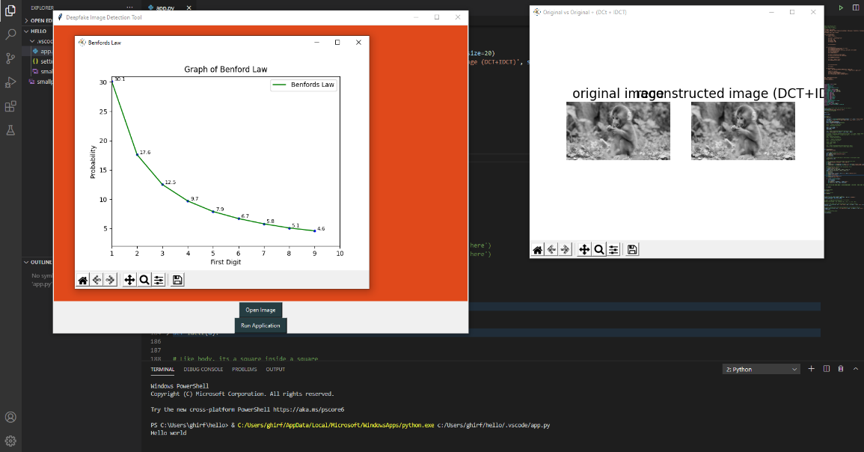
A few months have passed and now we have a rectangle with a pop out of matplotlib graph, on the right is some verification process, it’s been improved since. I think the graph being inside the Tkinter window shows some connection

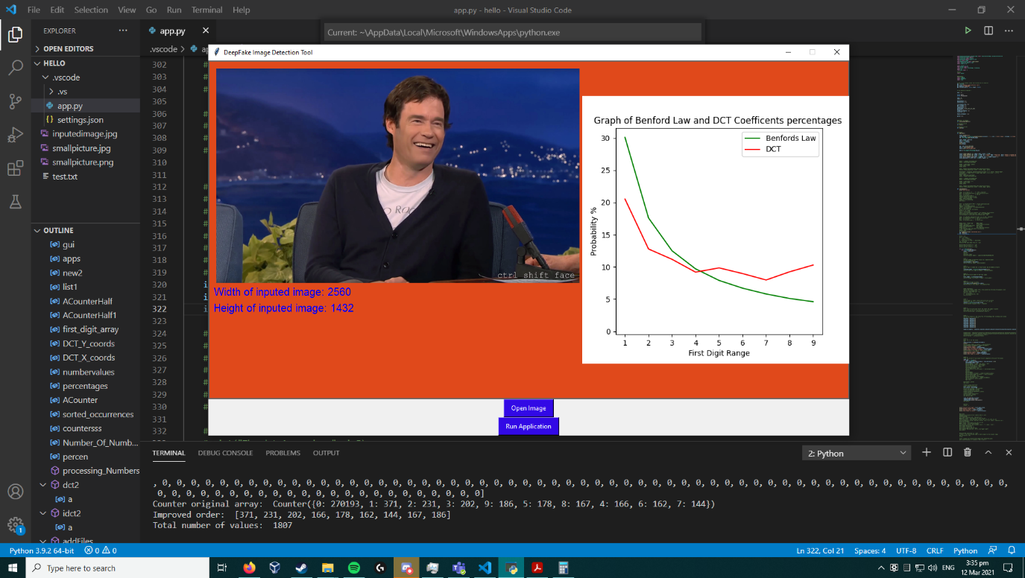
Near the end of submitting my project, a fully formed window with image display has bee made. The matplotlib graph now live updates the user with accurate data
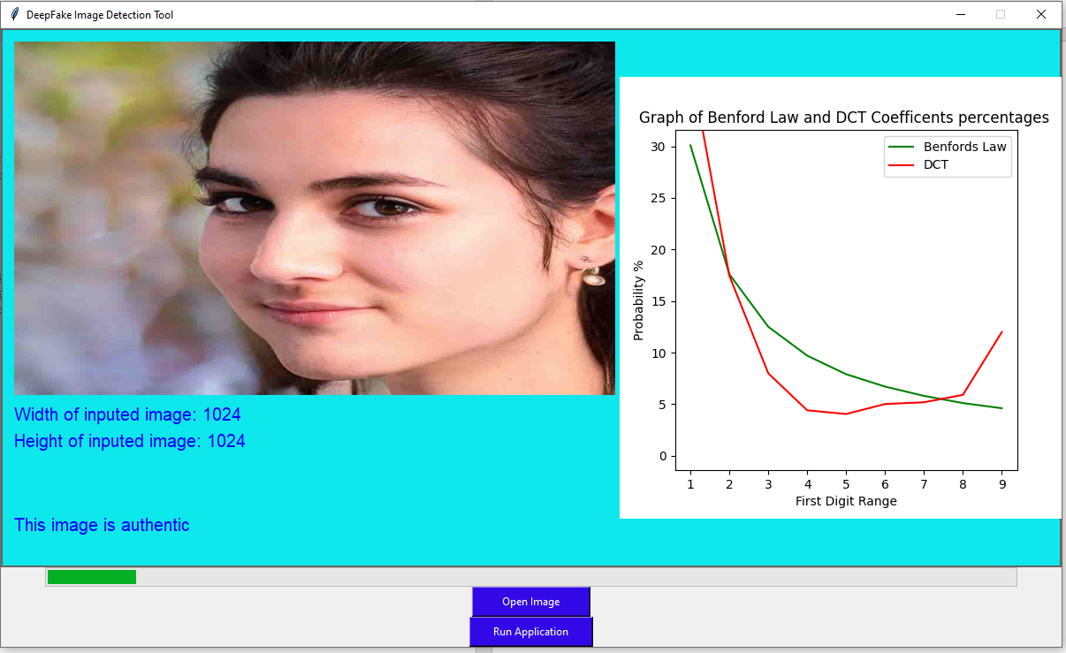
My final iteration, blue seems a bit softer and friendlier. It now has a progress bar that shows the progress over time to let users know of how the progress is being made in the background. Bigger buttons for anyone with poor eyesight. Pixel size displays if the user is wondering.
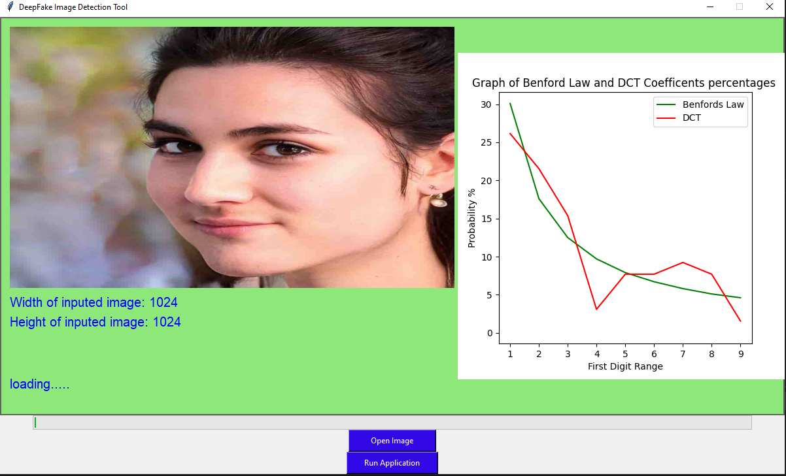
Finally settled on a green neutral colour.
Simple browse files and enter an image
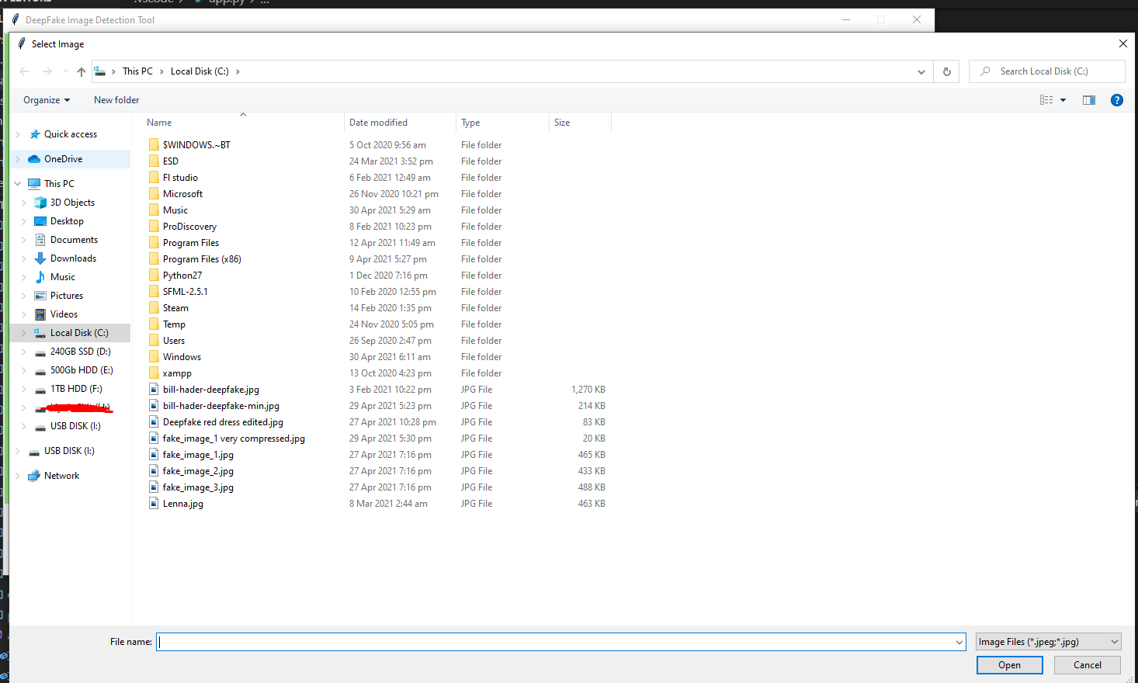
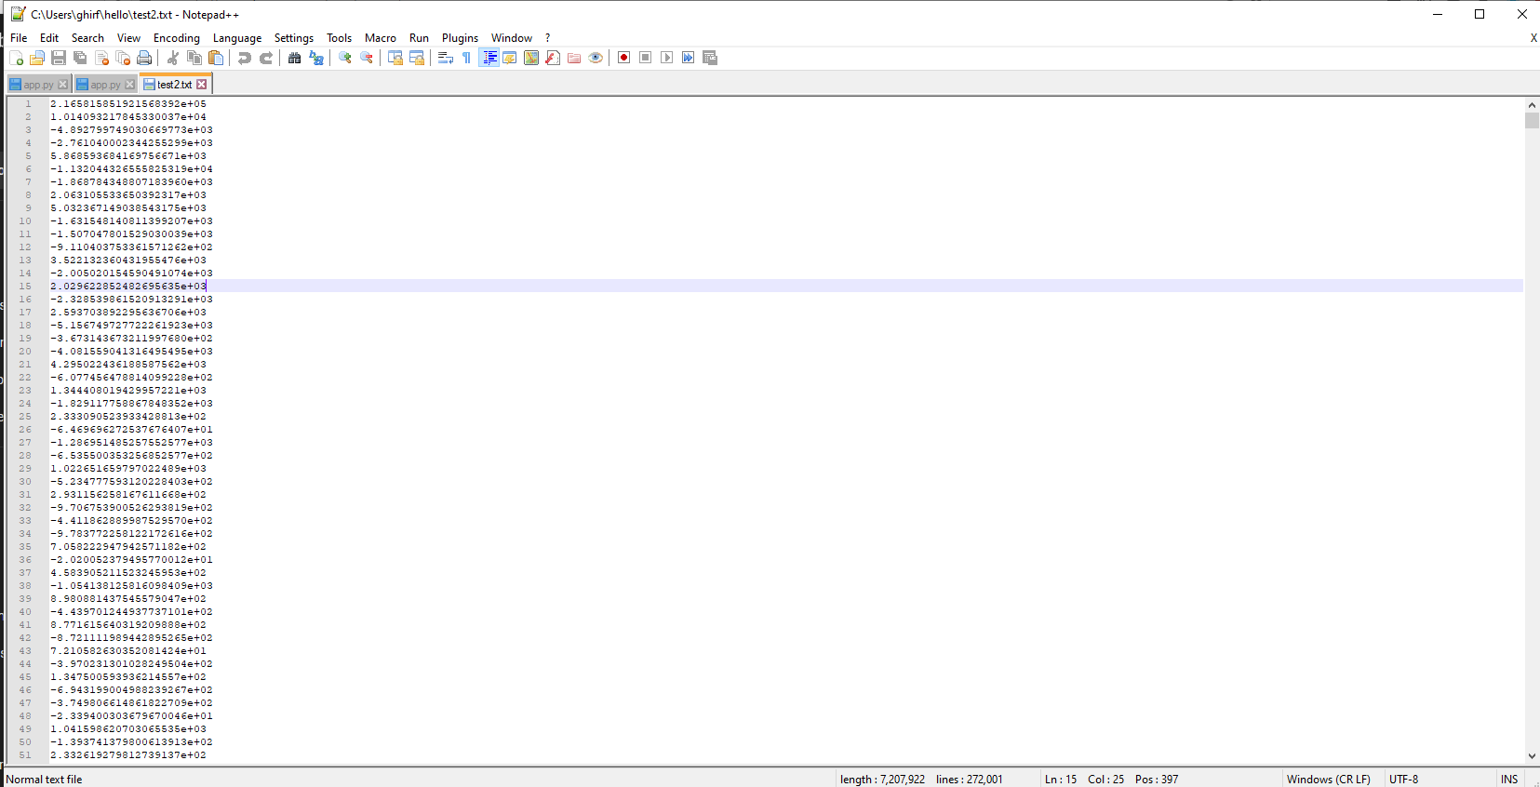
The DCT number are saved to text2.txt in case the user wants to see the digits after calculations

